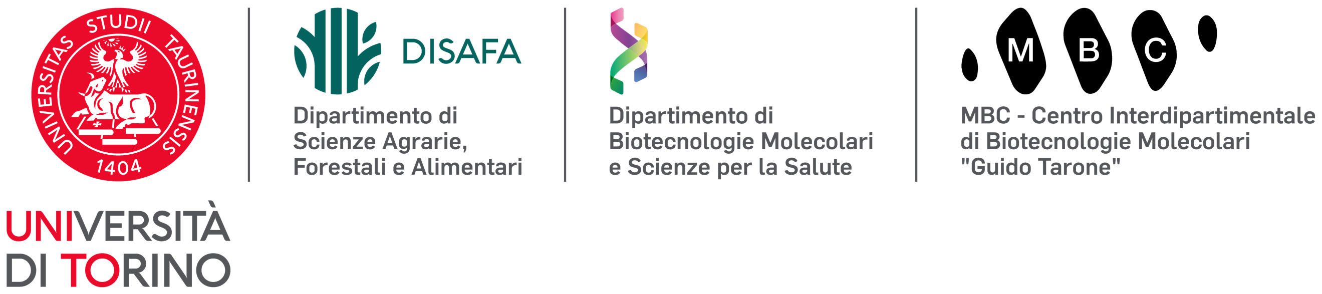 | 
VII Convegno AISSA#under40
Torino, 8-9 Luglio 2026
Presente e futuro delle scienze agrarie, forestali e alimentari:
sfide e prospettive per le nuove generazioni
Title
Name Surname ¹, Name Surname ^{2*}, …
¹ Department of Agricultural, Forest and Food Sciences (DiSAFA) – University of Turin, Largo P. Braccini 2, 10095 Grugliasco (TO), Italy
² Department of Molecular Biotechnology and Health Sciences (DBMSS) – University of Turin, Via Nizza 52, 10126 Torino, Italy
* Corresponding author: Name Surname (e-mail)
Abstract. A maximum of 300 words in English (no tables, figures and references allowed). We are pleased to welcome you to the VII AISSA#under40 Conference, which will be held in Turin in July 2026. We are confident that your participation will contribute to a stimulating and enriching experience for all attendees.
Keywords: a maximum of five, please use a semicolon to separate them.

––––––––––––––––––––––––––––––––––––––––––––––––––––––––––––––––––––––––––––––––
Please note
The file must be named SURNAME_Name_01.docx
If the author wishes to submit another abstract, the second one must be named SURNAME_Name_02.docx
File(s) must be sent to aissa40web2026@gmail.com

Key information
Preferred mode of presentation: Oral, Poster o Short communication
Academic qualification of the proposer: Dottorando/a, Assegnista di ricerca, Borsista, altro…
Settore scientifico disciplinare (SSD): Example AGRI-04/B (meccanica agraria)

